CREDIT SCORING MODEL

BUSINESS CASE: CREDIT RISK MODELLING

XYZ Pvt Ltd bank intends to create its own in-house risk model to make lending decisions based on past credit score.

* Business model objective is to create maximum profit.
* Bank has shared its credit bureau records of its customers.

CREDIT RISK CHART:

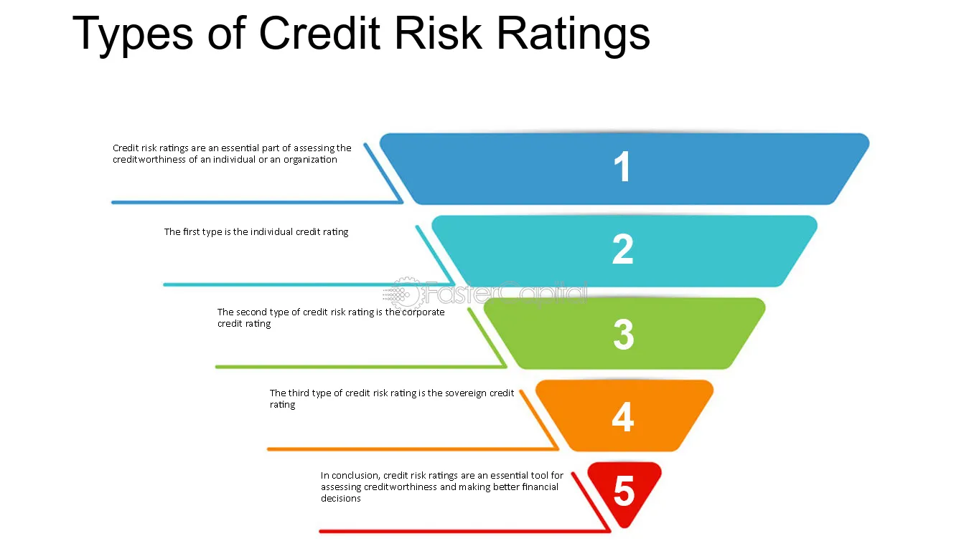

Credit risk chart indicates top most label as importance of creditworthiness and its different types and what tools can be used for assessing the risk.

OUR APPROACH

* ASSUMPTIONS

We need to consider the missing values imputed with mean. Also include the customer ID excluded from analysis.

* TRAINING MODEL

The model should predicting the likelihood of loans being good/bad and also using Logistic Regression Classifier.

IN-HOUSE RISK MODEL

